Aspiring Scientists Training Programme
Job Description

About the Gurdon Institute
The Gurdon Institute is a world-leading centre for research into the biology of development and how normal growth and maintenance can go wrong in diseases such as cancer. Many of our scientists have made pioneering contributions to the fields of basic cell biology, cellular reprogramming, epigenetics, and DNA repair.

This programme is funded by the University’s Widening Participation programme with the particular aim to give students the experience of working in an academic research environment when they ordinarily wouldn’t be able to arrange such an experience on their own.
Dates of Placement
 | 10th – 15th July, 2022
Placement Description
Area of the Gurdon | Laboratory research
What will you do? | Spend 3 hours in the lab each day  Attend four, two-hour interactive workshops to help you develop scientific and practical skills (e.g. microscopy, image analysis, presentation skills, how to apply to selective universities)  Create and deliver a scientific presentation to other placement students.  You will also have the opportunity to network with post-graduate students and scientists, talk to them about their jobs and lives and find out how research is done in the lab.

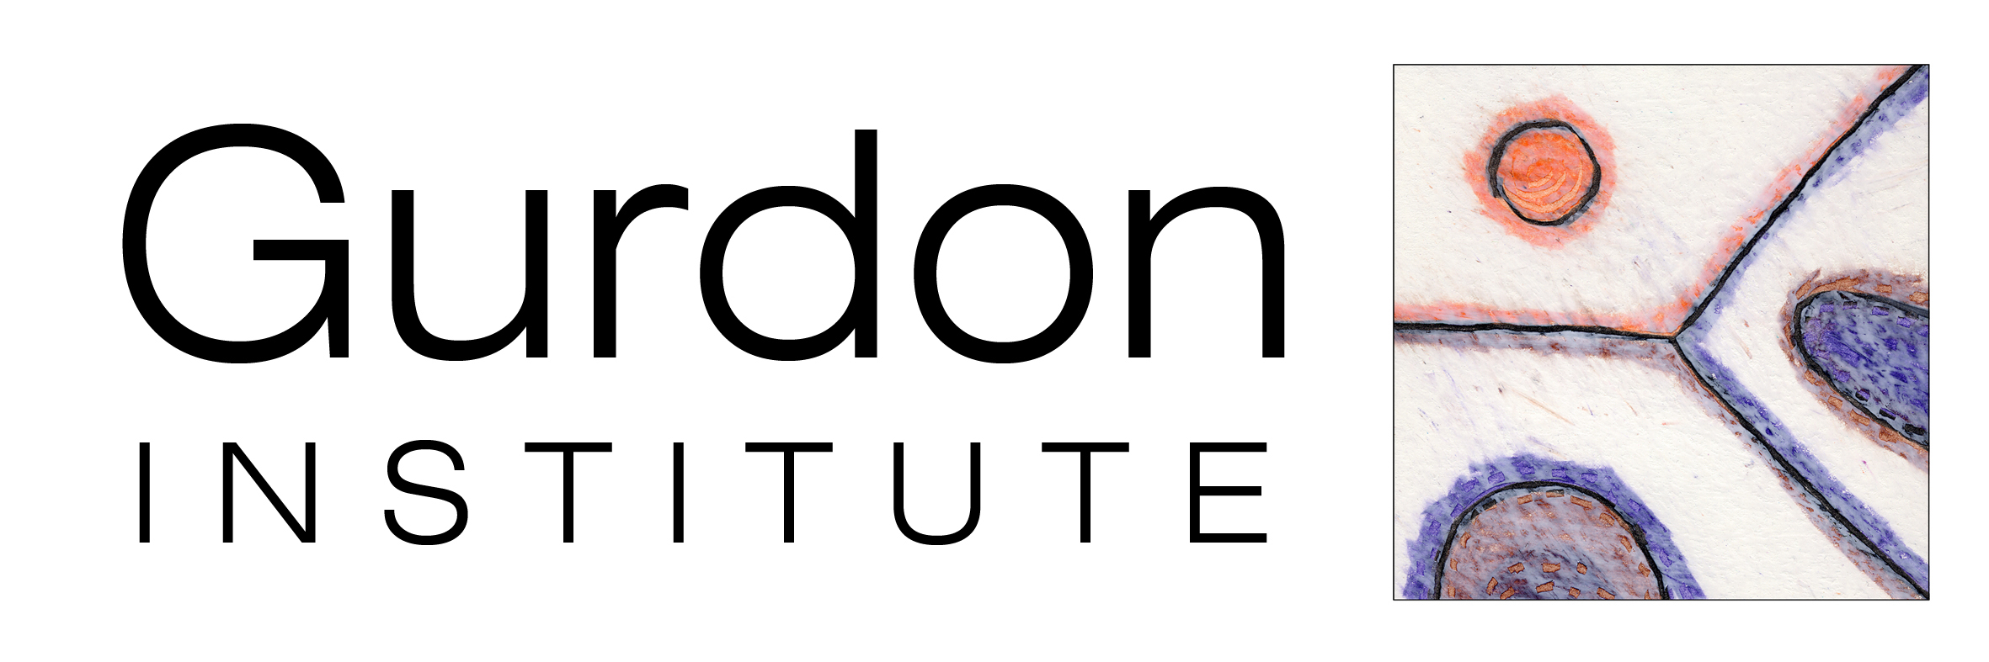
About the successful student
We expect all students to be punctual, responsible, reliable, curious, and willing to listen to advice and act on feedback.

You must be available for all of the days during the placement week.
Interested in: | Biology
Key skills include: | Attention to detail, interested, inquisitive
What you will need
You will need to bring | Closed-toed shoes  Sensible clothing and a hair band if necessary
We will provide | Lab coat  Protective eyewear  Gloves  Computer access (where necessary)  Free lunch at the Institute (up to £10 per day)  Transportation reimbursement (receipts required, up to £50 per week unless previously discussed with the project team)  Accommodation (Sunday – Thursday night of your placement week)
Questions?
If you have any questions about this job description, the work experience programme or the application process, please reach out to Natalie at workexperience@gurdon.cam.ac.uk

